**PROJECT REPORT OF**

**WEB DEVELOPMENT FRAMEWORK USING PYTHON (24CAI0105)**

**ON**

Blood Management System

**BACHELOR OF ENGINEERING**

**In**

**COMPUTER SCIENCE AND ENGINEERING (ARTIFICIAL INTELLIGENCE)**

**Submitted by: Supervised By:**

**Yashu Singla 2410993076 Mr. Pavan Ambulkar**

**Yuvraj Garg 2410993081 (Assistant Professor)**

**Ishmeet Singh 2410992764**

**Dhritvan Garg 2410993010**



**DEPARTMENT OF COMPUTER SCIENCE AND ENGINEERING**

**(ARTIFICIAL INTELLIGENCE)**

**CHITKARA UNIVERSITY INSTITUTE OF ENGINEERING AND TECHNOLOGY**

**CHITKARA UNIVERSITY, PUNJAB, INDIA**

**CONTENTS**

|  |  |  |
| --- | --- | --- |
| S.No. | Title | Page No. |
| 1. | Acknowledgement | 4 |
| 2. | Abstract | 5 |
| 3. | Introduction | 6 |
| 4. | Methodology | 7 |
| 5. | Tools and Technologies | 8 |
| 6. | Implementation | 9-12 |
| 7. | Major Findings/Outcomes/Output/Results | 13 |
| 8. | Conclusion and Future Scope |  |
| 9. | References |  |
| 10. | Appendices |  |

**DECLARATION**

I hereby certify that the work which is being presented in the project report entitled **“Blood Management System”** in partial fulfilment of requirement for the award of the degree of Bachelor of Engineering (Computer Science and Engineering) submitted in the Department of Computer Science and Engineering(Artificial Intelligence) at Chitkara University Institute of Engineering and Technology, Chitkara University, Punjab, India, is an authentic record of my own work carried out under the supervision of Mr. Pavan Ambulkar. The matter presented in this project report has not been submitted in any other university/institute for the award of any degree.

Place: Rajpura **(Yuvraj Garg)**

Date : 5-5-2025 (2410993081)

This is to certify that the above statement made by the candidate is correct to the best of my knowledge and belief.

**Mr. Pavan Ambulkar**

Assistant Professor

Department of Computer Science and Engineering (Artificial Intelligence)

Chitkara University Institute of Engineering and Technology,

Chitkara University, Punjab, India

**ACKNOWLEDGEMENT**

I would like to extend my sincere gratitude to everyone who contributed to the successful completion of this web development project, which involved the use of Flask, Django, and various APIs.

First, I would like to express my deepest thanks to my Web Development Professor, Mr. Pavan Ambulkar, for their constant support, expert guidance, and invaluable feedback. Their mentorship was crucial in overcoming technical challenges and enhancing my understanding of both Flask and Django frameworks.

I would also like to acknowledge the contributions of [Yashu Singla, Ishmeet Singh, Dhritvan Garg] for their teamwork and dedication throughout the project. Working together has made the development process both efficient and enjoyable.

A special thanks to the creators and maintainers of Flask and Django. These powerful frameworks provided the necessary foundation for building a robust and scalable application. Additionally, the use of [REST APIs, third-party APIs, etc.] was integral to adding advanced functionality and improving the overall user experience.

I am also grateful for the documentation and community resources surrounding Flask, Django, and API integration, which helped me resolve challenges and implement best practices throughout the project.

Lastly, I would like to thank my family and friends for their unwavering support, patience, and encouragement during this endeavor.

This project would not have been possible without the collective effort and guidance of all involved, and I am truly appreciative of everyone's contribution.

**ABSTRACT**

This project presents the design and development of a Blood Management System (BMS) intended to streamline and improve the process of blood donation, collection, storage, and distribution in hospitals and blood banks. The BMS is a web-based application aimed at facilitating the management of blood inventory, tracking donations, ensuring proper blood allocation, and providing real-time updates on blood availability. The system offers functionalities for users to register as blood donors, schedule donation appointments, and monitor the status of their contributions. It also provides administrators with tools to manage donor information, monitor stock levels, issue blood requests, and generate reports.

The project is built with a user-friendly interface, ensuring seamless interaction for both the donors and healthcare professionals. The system integrates a secure database to store sensitive data, providing data privacy and integrity. It also includes features like automated reminders for blood donation drives, notifications for stock levels, and a dashboard for easy tracking of blood inventory. By automating critical processes and enhancing communication, this Blood Management System aims to reduce operational inefficiencies, improve patient care, and contribute to a more effective and responsive healthcare system.

This report provides an overview of the system's architecture, design decisions, technologies used, implementation process, and testing procedures, along with an analysis of the system's potential impact on blood management in healthcare institutions.

1. **Introduction**

A Blood Management System (BMS) is an essential tool in modern healthcare settings, aimed at ensuring the efficient collection, storage, and distribution of blood. The proper management of blood resources is crucial for saving lives in medical emergencies, surgeries, and treating patients with various conditions such as anemia, cancer, and trauma. However, the existing systems for managing blood donation and supply often face challenges such as inventory mismanagement, lack of real-time updates, and inefficient allocation processes.

This project proposes the development of a web-based Blood Management System (BMS) to address these challenges. The system will streamline the entire blood donation and management process, providing a user-friendly platform for both donors and healthcare professionals. Donors can register, schedule appointments, and track their donations, while administrators can manage donor data, monitor blood stock levels, allocate blood efficiently, and generate reports.

The main goal of this system is to automate and centralize the blood donation process, reducing manual errors, improving inventory management, and ensuring that blood is available when and where it is needed. By utilizing a secure database and real-time notifications, the system ensures that blood banks can maintain an adequate supply, improve donor engagement, and enhance overall operational efficiency.

This report outlines the design, features, and implementation of the Blood Management System, which aims to contribute significantly to improving the quality and responsiveness of blood supply management in hospitals and blood bank.

**2. METHODOLOGY**

2.1 The primary aim of the Blood Management System is to transform the way blood donation, storage, and request processes are managed by creating a secure, efficient, and interactive web platform. Designed for both healthcare institutions and voluntary donors, this system simplifies the end-to-end flow of blood availability, ensuring that critical needs are met with speed, transparency, and accuracy. The platform is built to bridge the communication gap between donors, hospitals, and administrators in real time.

2.2 The system enables features such as donor registration, blood request submissions, real-time inventory tracking, and approval workflows. Each user—be it a donor, hospital, or admin—receives a personalized dashboard, allowing them to interact only with data relevant to their role. This modular structure promotes both data privacy and efficient task handling. Features like blood type filtering, donation history, and automated notifications are integrated to reduce human error and streamline operations.

2.3 In addition to its functional strength, the platform is designed with a user-centric interface using modern web technologies. The design incorporates responsive layouts and clean UI components to make navigation intuitive, even for non-technical users. Animations and visual feedback provide a seamless experience across devices, turning what is often a stressful process into one that is clear and manageable.

2.4 Scalability and security are key considerations. The backend architecture allows for the expansion of users, data, and features without compromising performance. Built-in authentication mechanisms safeguard sensitive medical and personal data, ensuring that only authorized users can access the system. The system is flexible enough to serve not only local blood banks and clinics but also scale to regional and national networks in the future.

2.5 The development process of the Blood Management System involved extensive self-driven research, utilizing a wide range of web development tutorials, forums, open-source repositories, and educational platforms. Technologies such as Flask, Django, RESTful APIs, and relational databases were explored and applied effectively to achieve the project goals.

2.6 Ultimately, this Blood Management System is more than just a web application—it is a step toward modernizing healthcare infrastructure through digital innovation. It ensures that the process of saving lives through blood donation is managed with precision, reliability, and empathy. By integrating performance, design, and usability, the system is built not only to function efficiently but to make a meaningful impact in critical situations.

**3. TOOLS AND TECHNOLOGIES**

**3.1 Flask for building lightweight backend modules**

Flask is used for developing specific backend components of the Blood Management System where quick development and minimal complexity are essential. It is ideal for handling tasks such as API routing, donor form submissions, and basic user interactions in a clean, modular way. Flask’s simplicity supports faster iteration and integration with other backend logic.

**3.2 Django for full-featured backend development**

Django serves as the primary backend framework for core system modules, including authentication, blood inventory management, and administrative control. Its MVT (Model-View-Template) architecture, built-in ORM, and security mechanisms ensure that the platform is both scalable and secure. Django’s admin interface also simplifies data management and backend operations.

**3.3 API (Application Programming Interface) for smooth communication.**

RESTful APIs were developed using Flask-RESTful and Django REST Framework to allow seamless data communication between the frontend and backend. These APIs are responsible for handling blood requests, updating stock levels, managing user accounts, and filtering blood types. This approach ensures a decoupled, maintainable structure and enables future integration with mobile apps or third-party systems.

**3.4 SQL and Database Schema for structured data management**

The system uses SQL-based databases such as SQLite (for development) and MySQL (for production) to manage structured data like donor records, hospital profiles, blood inventory, and request history. A well-defined relational schema with primary and foreign keys ensures data integrity and efficient querying across different modules.

**3.5 HTML (HyperText Markup Language) for structuring web content**

HTML is used to define the structure of all web pages within the system, including user dashboards, registration forms, blood request interfaces, and inventory tables. It ensures consistent layout and seamless integration with server-rendered content using Django templates.

**3.6 CSS (Cascading Style Sheets) for design and layout**

CSS provides styling for the Blood Management System’s user interface. It is used to format forms, dashboards, tables, and alert messages, ensuring that the application is visually consistent and easy to navigate. Responsive design techniques help maintain usability across different screen sizes.

**3.7 Bootstrap for responsive and modern frontend design**

Bootstrap is utilized to speed up frontend development by offering ready-made components such as navigation bars, buttons, forms, and modal windows. Its responsive grid system ensures that the platform looks clean and works well on all devices, from desktops to smartphones.

1. **IMPLEMENTATION**

**4.1 Problem Statement**

Efficient blood management is vital to the functioning of healthcare systems. However, traditional blood bank operations suffer from outdated methods, fragmented communication, and lack of digital infrastructure. These limitations can lead to delays in emergency responses, unfulfilled requests, and inefficient donor engagement. The Blood Management System aims to overcome these critical gaps by providing a comprehensive, secure, and user-centric web-based solution for managing blood donations, requests, and inventory tracking.

**The key problems identified are:**

**4.1.1 Lack of Real-Time Blood Inventory Visibility**

Many hospitals and blood banks maintain manual or siloed records, which leads to an inability to track blood stock levels accurately. This results in delays during emergencies or in cases of rare blood type shortages.  
The Blood Management System solves this by offering real-time visibility into the availability of different blood types, streamlining emergency decision-making.

**4.1.2 Poor Donor Engagement and Accessibility**

Traditional systems offer no digital platform for regular or potential donors to register, track their donation history, or receive alerts. This discourages consistent participation in donation drives.  
The proposed system allows donors to create accounts, view eligibility status, and receive timely notifications about donation events, enhancing participation and retention.

**4.1.3 Inefficient Blood Request Processing**

Blood requests are often handled manually or over the phone, resulting in communication delays and lack of traceability. There is also no centralized system to monitor request fulfillment.  
The system introduces a digital request portal for hospitals, enabling easy submission, tracking, and approval of blood requests, with status updates and history logs.

**4.1.4 No Role-Based Access or Data Segmentation**

Existing systems often do not provide differentiated access for admins, hospitals, and donors, which can lead to data exposure or misuse.  
This system implements strict role-based access controls, ensuring that each user type (admin, hospital, donor) can only interact with their relevant data and functionality.

**4.1.5 Outdated Interfaces and Usability Issues**

Current blood bank platforms often have outdated, non-intuitive interfaces that hinder adoption, especially by users with limited technical skills.  
The Blood Management System offers a clean, responsive interface with simplified navigation, making it accessible for all user types regardless of technical proficiency.

**4.1.6 Lack of Scalability for Expanding Networks**

Manual and poorly designed systems cannot efficiently scale to support regional or national blood networks, leading to performance degradation.  
This system is built with scalability in mind, supporting a growing number of users, requests, and blood banks without impacting performance.

**4.1.7 Insufficient Security Measures for Sensitive Data**

Healthcare and donor data are sensitive, and many existing systems lack proper authentication and encryption protocols.  
This system employs secure login mechanisms, encrypted data storage, and access logs to ensure data confidentiality and integrity.

**4.1.8 Fragmented Workflow Between Stakeholders**

In many settings, there is no centralized platform where donors, hospitals, and administrators can coordinate blood-related activities, leading to inefficiencies.  
The Blood Management System unifies these stakeholders under one system, ensuring a connected and efficient workflow from donation to transfusion.

**4.2 Working**

**4.2.1 Donor Registration and Management**

The Blood Management System allows individuals to register as blood donors through a secure online form. Donors provide essential information such as blood type, contact details, and last donation date. The system validates donor eligibility and maintains a history of their donations. This helps streamline the process of identifying eligible donors during emergencies and improves donor retention through proper record-keeping.

**4.2.2 Blood Inventory Management**

The system offers centralized control over blood stock data across multiple blood banks or hospitals. Admins can add, update, or remove blood units by type, quantity, and expiry date. Automated low stock alerts help in timely replenishment of critical blood types. The platform also categorizes inventory by blood groups and components (e.g., plasma, platelets), ensuring efficient and precise management.

**4.2.3 Blood Request and Approval Workflow**

Hospitals can submit blood requests directly through the system by specifying the required blood type, quantity, and urgency level. The system checks real-time stock availability and routes the request to the appropriate administrator for approval. Once approved, the requested units are marked and the inventory is updated. This streamlined request process reduces manual effort and response time during medical emergencies.

**4.2.4 Hospital and Organization Management**

Hospitals and medical organizations are onboarded with verified credentials. Each organization gets a secure login and dashboard to manage blood requests, view stock availability, and track pending or fulfilled requests. This ensures accountability and a smooth flow of operations between hospitals and the central system.

**4.2.5 Donor Notifications and Alerts**

Donors receive automatic notifications via email or SMS when they are eligible to donate again, or when a specific blood group is urgently needed. This feature encourages timely donations and improves donor engagement. Additionally, reminders help reduce the chances of blood shortages by keeping the donor base actively involved.

**4.2.6 Admin Dashboard and Analytics**

Administrators have access to a powerful dashboard that displays real-time insights into available stock, pending requests, active donors, and hospital activity. Graphical analytics help identify trends, such as high-demand blood types and donation frequency. These insights support better planning and quicker decision-making in crisis scenarios.

**4.2.7 Role-Based Access Control**

The system supports role-based access to maintain security and data integrity. Different user roles such as admin, donor, and hospital have distinct permissions. For example, donors can only view their personal history, hospitals can only submit and track their requests, while admins manage the entire platform and data. This ensures that users access only what is relevant to their roles.

**4.2.8 Blood Donation History and Tracking**

Each donation is logged with the date, donor name, blood group, and recipient hospital (if applicable). This history provides traceability and helps in auditing, compliance, and medical tracking. Donors can also view their personal donation timeline and frequency, which fosters transparency and trust.

**4.2.9 Responsive and User-Friendly Interface**

The Blood Management System is designed with a clean and responsive interface, ensuring accessibility across desktops, tablets, and smartphones. Whether a donor is registering from home or a hospital staff member is requesting blood in an emergency, the platform delivers a smooth and intuitive user experience.

**4.2.10 Manual Monitoring of Stock and Expiry**

In the Blood Management System, administrators can manually monitor blood unit stock levels and expiry dates through a structured inventory table. Each entry includes the blood type, quantity, and expiry information, allowing staff to routinely review and take appropriate action. While the system does not send automated alerts, the clear presentation of expiry data enables timely decision-making to minimize wastage and ensure optimal stock usage.

1. **MAJOR FINDINGS/OUTCOMES/OUTPUTS/RESULTS**

**5.1 Improved Blood Inventory Tracking:** Real-time tracking of blood stock levels ensures hospitals can instantly check available units, reducing errors and improving accuracy.

**5.2 Enhanced Efficiency in Blood Request and Fulfillment:** Automation of blood request processes minimizes manual effort, streamlining approval and fulfillment, especially during emergencies.

**5.3 User-Friendly Dashboard and Interface:** A clean, intuitive interface allows users to easily monitor stock, track donation history, and manage requests.

**5.4 Improved Donor Engagement and Retention:** Automated reminders and donation tracking encourage repeat donations and improve donor participation.

**5.5 Reduced Waste and Optimized Blood Usage:** Real-time monitoring of expiry dates helps prioritize the use of units near expiration, minimizing waste and ensuring efficient stock management.

**5.6 Data Analytics & Insights for Better Decision-Making:** Analytics tools provide valuable insights into donation trends and inventory turnover, supporting better planning and decision-making.

**5.7 Security and Role-Based Access Control:** Strong data security and access control prevent unauthorized changes, ensuring the integrity and confidentiality of the system.

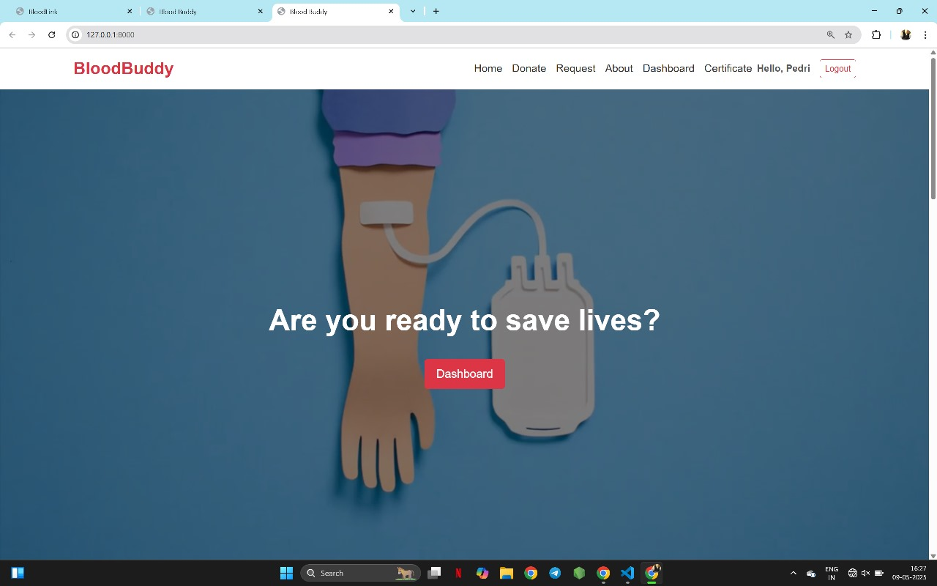

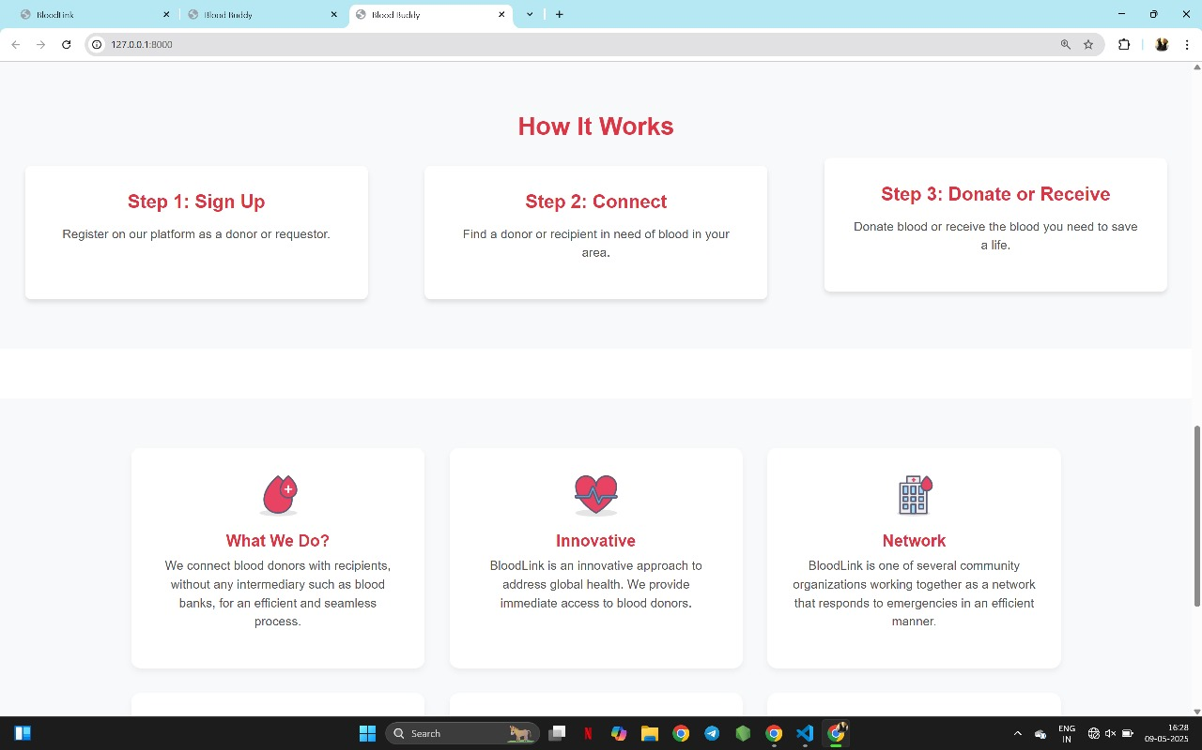

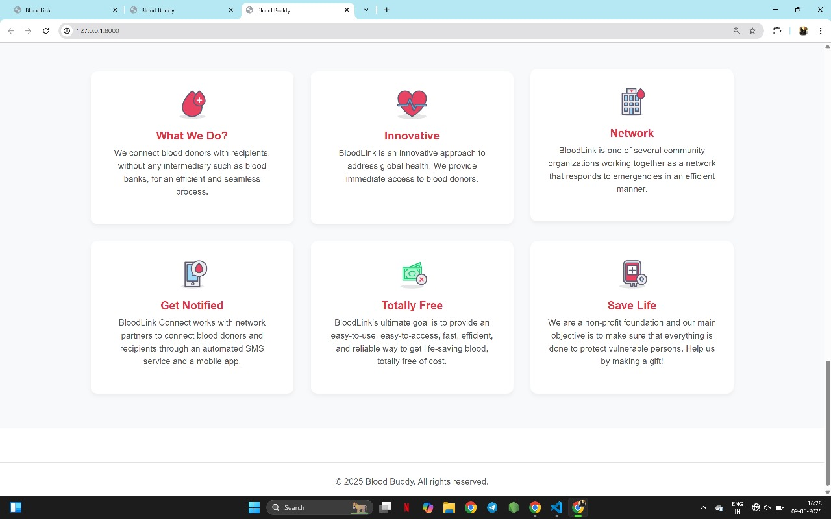

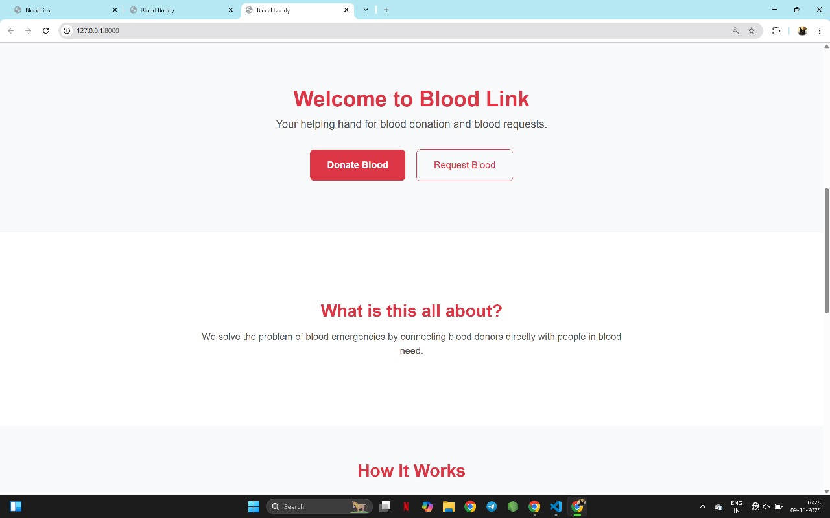

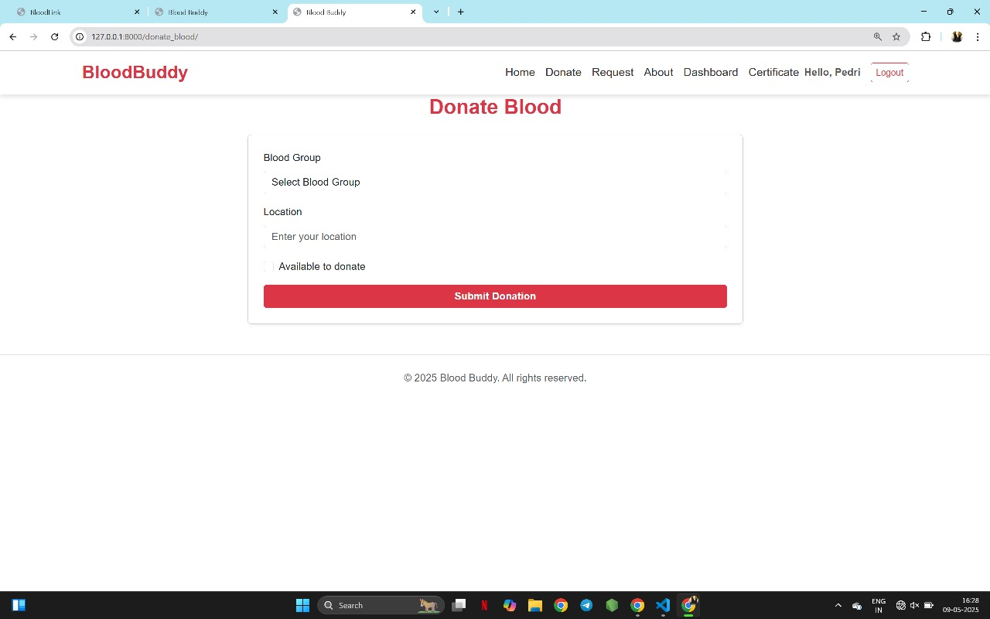

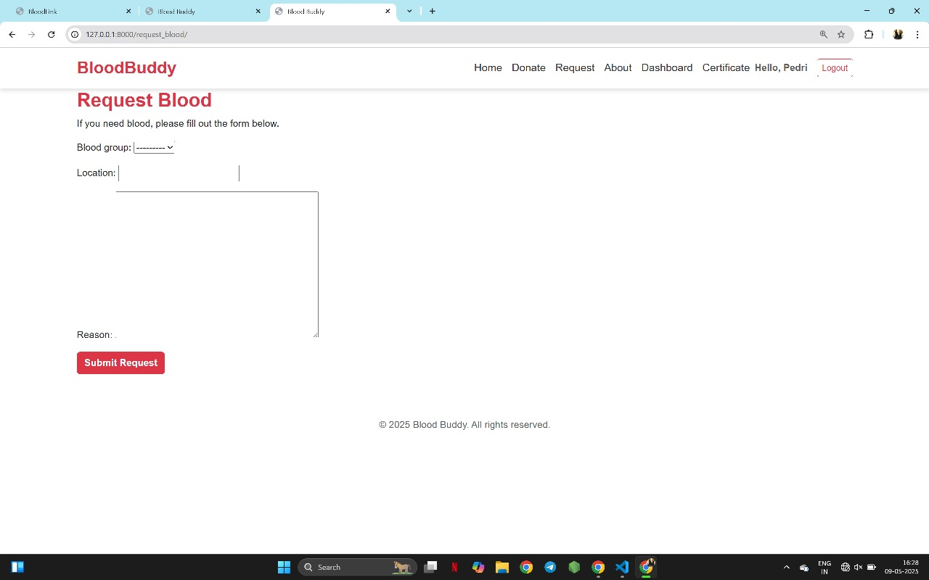

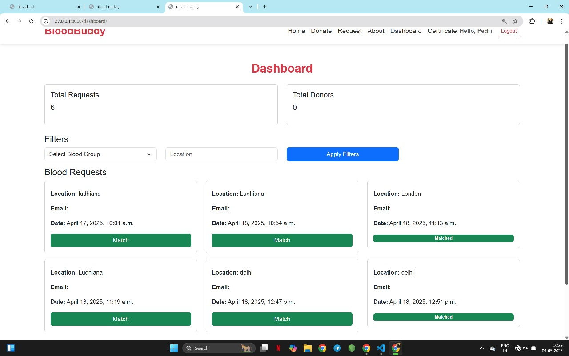

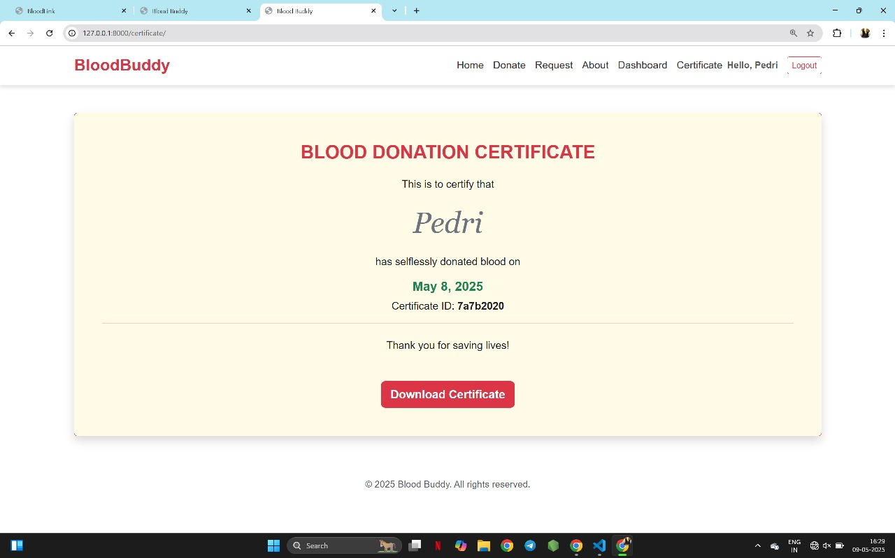

1. **CONCLUSION AND FUTURE SCOPE**

**6.1 Conclusion**

The Blood Management System significantly enhances the way blood donations, inventory, and requests are managed in hospitals and blood banks. Key outcomes include:

* Improved Efficiency: By automating blood request processing, inventory tracking, and donor management, the system reduces manual tasks and ensures faster response times, especially in emergency situations.
* Optimized Blood Usage: The system helps reduce wastage by closely monitoring blood expiry dates and prioritizing the use of units nearing expiration, ensuring that no resources are wasted.
* Enhanced Decision-Making: Real-time data on available blood stock, donation trends, and hospital requests enable better planning and decision-making to meet patient needs promptly.
* Streamlined Operations: The platform integrates various functions such as donor registration, blood request handling, and inventory management, creating a seamless workflow for hospital staff.
* Improved Donor Engagement: Automated notifications, easy donation history tracking, and eligibility reminders enhance donor retention and participation, ensuring a steady blood supply.

**6.2 Future Scope**

The future development of the Blood Management System holds great potential for further improvements and wider adoption in healthcare settings:

* AI-Powered Predictive Analytics: Machine learning algorithms can be implemented to predict blood demand based on historical data and trends, helping blood banks anticipate shortages or excesses before they occur.
* Cloud Integration: Migrating the system to the cloud can enhance accessibility, allowing hospital staff and blood banks to access and update information from any location, enabling better coordination between different facilities.
* Mobile Application Development: A mobile app could be developed for donors to register, track their donations, and receive notifications, providing a more flexible and user-friendly experience for mobile users.
* Automated Blood Collection Scheduling: Implementing automated scheduling for blood donation drives based on demand and donor availability can streamline the collection process and optimize the donation cycle.
* Enhanced Security Measures: Further strengthening the system’s security with advanced encryption, multi-factor authentication, and compliance with healthcare data regulations (like HIPAA) will ensure the highest levels of data privacy and protection.

**REFERENCES\LINKS USED**

References used in the project are :-

* Sir Pavan Ambulkar’s provided course notes
* W3Schools website
* Several YouTube channels like :-

CodeWithHarry

LoveBabbar

**Appendices**

***GITHUB LINK:***

**Thank You**